Components
MLflow has 4 components:
- Tracking – log experiments and metrics
- Projects – packaging code
- Models – managing ML models
- Registry – central store for versioned models

MLflow Tracking
Tracking is a centralized experiment logger where you track:
- Parameters: Hyperparameters like learning rate, batch size, etc.
- Metrics: Accuracy, loss, AUC, any numeric measure
- Artifacts: Model files, plots, datasets, any output file
- Source info: Git commit hashes, code version, who ran it, when
You log these from your training scripts with the MLflow client API (mlflow.log_param(), mlflow.log_metric(), etc.).
You can then visualize and compare experiments in the MLflow UI.
For tracking we are using 3 components:
- A backend store
- An artifact store
- MLflow Server (Tracking Server)

A backend store
- usually a SQL DB like MySQL, Postgres, or SQLite
- Stores metadata:
  - Experiment info
  - Run UUIDs
  - Parameters
  - Metrics
  - Tags
  - Run start/stop times

An artifact store
- For example Azure Blob Storage, AWS S3, local FS
- Stores files:
  - Saved models
  - Plots
  - Logs

MLflow Server (Tracking Server)
- Provides UI
- Clients (your scripts or projects) send data here
- It orchestrates:
  - Logging to the backend store
  - Uploading to the artifact store
  - Serving the web UI to browse runs
We set up a Tracking Server with a single command:
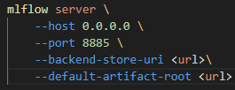

MLflow Project
This helps you package your ML code with all dependencies to make it reproducible and shareable.
That can include code for:
- Training models
- Preprocess data
- Run evaluations
We can specify parameters when running a project which will be used by the code (like hyperparameters).

Entry points
An entry point consist of a command and parameters used in that command. That command executes a function related to our ML model, for example a function for:
- Training models
- Preprocess data
- Run evaluations
Entry points are defined in a MLproject file. An example of how it looks like is in the next section ‘MLproject file’.

MLproject file
The MLproject file is a YAML file which describes:
- Project name
- Environment (conda, docker, or system)
- Entry points (commands for running scripts)
- Parameters (if any)
It can look for example like that:
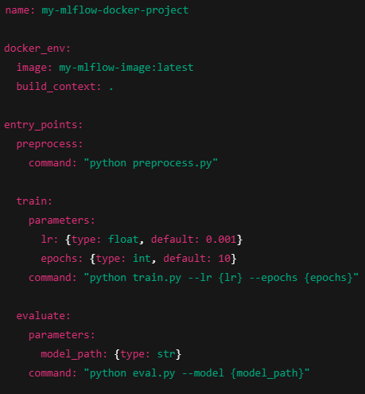

MLflow project content
Here is a typical folder structure for a MLflow project:
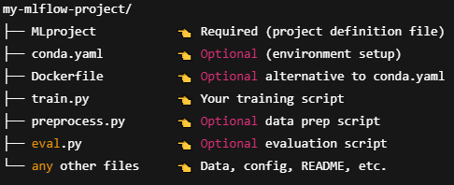

Docker
We can use Docker for preparing an environment where scripts (entry points) from the MLflow project will be executed.
In the MLproject file we can specify either a Dockerfile or a Docker image which will be used to prepare that environment.
Docker image which we want to use in the MLflow project can be saved either on our local computer or in a remote registry.

Deploying on Kubernetes
In order to run our MLflow project on Kubernetes we need to include a backend_config.json file in the MLflow project repository (in the same folder as Dockerfile) and provide the following parameters:
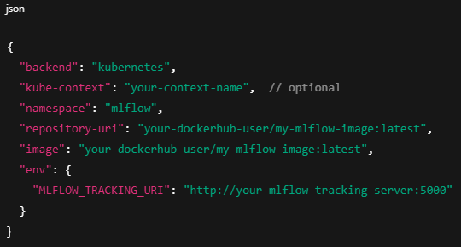
The kube-context parameter specifies which kube context we want to use (on which Kubernetes cluster to run a project).
Then we run our project using this command:
- mlflow run . -b kubernetes -P lr=0.01 -P epochs=5 --backend-config backend_config.json

MLflow Models
This component standardizes how you package, save, and load ML models regardless of framework (TensorFlow, PyTorch, Scikit-learn, XGBoost, etc.).
- Models are saved in a standard format, with metadata describing how to load and serve them
- Supports multiple deployment flavors (options for loading and serving a model) like Python function, REST API, Spark UDF, or even batch transforms
Saved models can be stored anywhere. One option is MLflow Registry.

MLflow Registry
A centralized model store where you manage the lifecycle of your ML models:
- Versioning: Keep track of every model version registered
- Stage transitions: Move models through stages like Staging, Production, Archived
- Annotations & comments: Add notes or tags on model versions
- Deployment integration: Some frameworks can deploy directly from the registry
It basically brings model governance and collaboration to your ML pipeline.

